16-BIT
MULTIPLICATION

EXP NO: 7

AIM:
To write an assembly language program to
implement 16-bit multiplication using 8085 processor.

ALGORITHM:

1) Load
the first data in HL pair.

2) Move
content of HL pair to stack pointer.

3) Load
the second data in HL pair and move it to DE.

4) Make
H register as 00H and L register as 00H.

5) ADD
HL pair and stack pointer.

6) Check
for carry if carry increment it by 1 else move to next step.

7) Then
move E to A and perform OR operation with accumulator and register D.

8) The
value of operation is zero, then store the value else go to step 3.

PROGRAM:

LHLD
2050

SPHL

LHLD
2052

XCHG

LXI
H,0000H

LXI
B,0000H

AGAIN: DAD SP

JNC
START

INX B

START: DCX D

MOV
A,E

ORA D

JNZ
AGAIN

SHLD
2054

MOV
L,C

MOV
H,B

SHLD
2056

HLT

INPUT:


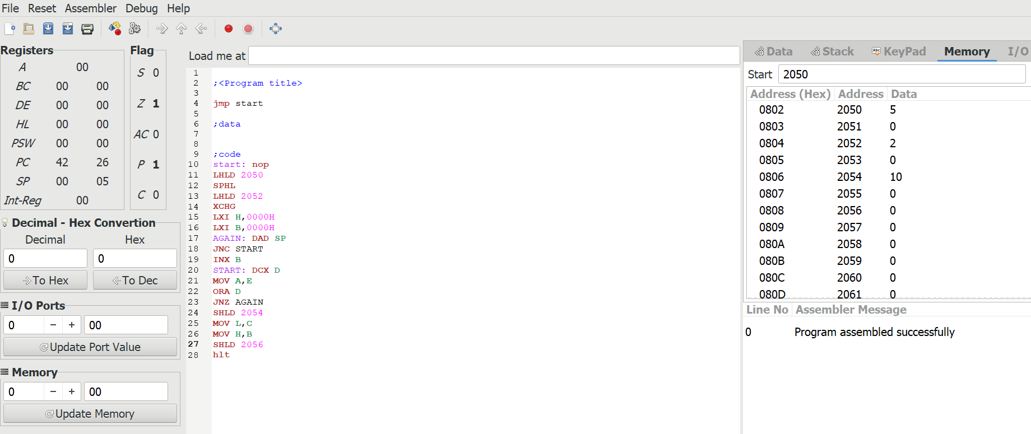

OUTPUT:

RESULT: Thus
the program was executed successfully using 8085 processor

